5/22/2025
Vladyslav Papin
glasgow clyde college
Requirements spec
Stage One :: Planning

Contents
1. Introduction 3
1.1 Purpose 3
1.2 Scope 3
1.3 Target Audience 3
1.4 Definitions and Acronyms 3
2. Chosen Development Life Cycle 3
2.1 Methodology 3
2.2 Sprint Structure 3
2.3 Risk Mitigation 3
3. Project Requirements 3
3.1 Functional Requirements 3
3.2 Non-Functional Requirements 3
3.3 Constraints 3
4. User Requirements 3
4.1 User Roles 3
4.2 User Workflows 3
4.3 Accessibility Needs 3
5. Design Specification 3
5.1 Style Guide 3
5.2 Viewport Widths 3
5.3 Wireframes 3
5.4 Navigation Map 4
5.5 Touch Gestures 5
6. Technologies Required 6
6.1 Front-End 6
6.2 Back-End 6
6.3 Database 7
6.4 Version Control 14
6.5 Testing Tools 14
7. Testing and Evaluation Planning 15
7.1 Testing Scope 15
7.2 Testing Methodologies 15
7.3 Success Metrics 15
7.4 Testing Schedule 16
7.5 Tools and Resources 16
8. Project Constraints 17
8.1 Technical Constraints 17
8.2 Resource Constraints 17
8.3 Time Constraints 17
8.4 Scope Constraints 18
9. Copyright Notes 19
9.1 Code Ownership and Licensing 19
9.2 Asset Copyright 19
9.3 User-Generated Content 20
9.4 Third-Party IP 20

1. Introduction

1.1 Purpose
The Obanshire Cub Scouts Organization Portal is a local website intended to enhance the scouting experience for Cubs, Leaders, and Parents/Carers in Obanshire, in addition to the national Cub Scouts website. Its primary purpose is to display up-to-date local information, coordinate scouting activities, and encourage interaction using interactive features. By offering features like badge management, photo galleries, and helper registration, the portal allows Cubs (6–14) to learn about scouting, Leaders to manage operations, and Parents/Carers to volunteer.

Scope
The portal delivers a media-rich, accessible website built with React and Tailwind CSS, with Obanshire-specific requirements as the priority. Key features are:
- Content: Local and generic Cub Scout information, searchable badge details with print facility, and a public photo gallery.
- User Management: Secure login with roles for Cubs (view only), Leaders (full access), and Helpers (event and availability management).
- Helper System: Signup
- Interactive Features: Scout-themed interactive games (e.g., matching, hangman, quiz, future stages in development)
- Privacy and Security: Restricted access to sensitive helper data (e.g., contact details) and secure login authentication.
The scope does not encompass backend integration with the national website but envisions a standalone prototype with scalability. Testing confirmed key features (e.g., badge search, photo upload) essential but also unearthed gaps like password recovery and mobile responsiveness for incremental enhancements.

1.3 Target Audience
There are three general user groups that the portal serves, each with varying requirements:
- Cubs (Ages 6–14): Young scouts seeking fun, age-appropriate material like badge information and games. To utilize the website, they must have simple navigation and engaging visuals (e.g., Tailwind CSS high-contrast themes).
- Leaders: Volunteer leaders of scouting activities, needing helper details (e.g., training levels) access, event management, and statistics. They enjoy role-adaptive dashboards but encountered issues with photo upload quality and Safari rendering.
- Helpers (Parents/Carers): Volunteers registering to assist, viewing events, and modifying availability. They require easy-to-use forms
- Generic information (e.g., becoming a helper) is viewed by all users, with accessibility features (e.g., WCAG 2.1 compliance) ensuring inclusivity, though with ARIA and keyboard navigation deficiencies.

1.4 Definitions and Acronyms
Cub Scout: A child aged 6–14 participating in scouting.
- Helper: A registered Parent/Carer volunteering for Obanshire Cub Scouts.
- WCAG: Web Content Accessibility Guidelines, aiming for Level AA compliance.
- LCP: Largest Contentful Paint, a measure of page load performance.
This portal will create an interesting, accessible scouting portal, addressing user needs through iterative design and test-based enhancements.

2. Chosen Development Life Cycle

2.1 Methodology
The Obanshire Cub Scouts Organization Portal was developed using the Agile methodology, as it was chosen because of its flexibility and iterative approach, which is appropriate for the dynamic needs of a user-centric site for Cubs, Leaders, and Parents/Carers.In contrast to linear methods like Waterfall, where specifications are defined early and are costly to change, Agile allows for continuous feedback and improvement. This is required for a portal requiring age-appropriate interfaces (e.g., large buttons for Cubs) and sophisticated features like badge management and helper registration.

2.2 Sprint Structure
Development was founded on two-week sprints with each addressing specific features and user feedback. A typical sprint included:
- Planning: Define goals (e.g., include badge search, streamline photo upload).
- Development: Build features using React and Tailwind CSS (e.g., role-based dashboards).
- Testing: Conduct functional, usability, and accessibility tests
- Review: Collect feedback from simulated users (Cubs, Leaders, Helpers) and stakeholders.
- Retrospective: Determine improvements
Sprints focused on high-priority features first, like secure login and badge management, then on interactive features like photo galleries. Testing feedback loops informed refinements, like correcting Safari rendering problems and enhancing form validation.
Regular weekly check-ins with stakeholders maintained alignment with
Obanshire's requirements, promoting rapid prototyping and iterative improvements.

2.3 Risk Mitigation
Agile's iterative nature reduced various risks:
- Accessibility Compliance: Detection of ARIA and keyboard navigation issues early allowed targeted fixes in subsequent sprints, reducing inclusivity risks.
- Mobile Performance: Cross-browser testing uncovered slow mobile LCP, prompting JavaScript minification and image compression plans.
- Feature Delays: Buffer time in subsequent sprints allowed for complex features (e.g., helper system) to be completed within schedule.
- User Feedback: Cubs, Leaders, and Helpers mock testing controlled usability risks, but validation with real users will be conducted in order to address form errors.
- Game Development: Scout-themed games (e.g., hangman, matching) were deferred to later phases due to scope constraints, with fallbacks for static badge content to maintain engagement.
With the flexibility of Agile, the portal minimized risks and maximized user satisfaction, laying the foundation for an enjoyable, scalable platform.

3. Project Requirements

3.1 Functional Requirements
The portal, built with React and Tailwind CSS, supports scouting activities through role-based features.. The table below details functional requirements, prioritized for implementation.
ID | Requirement | Description | Priority
FR-01 | User Authentication | Secure login/logout with role-based access (Cubs: view-only, Leaders: full, Helpers: restricted). | High
FR-02 | Badge Management | Search, view, print badge details; Leaders create/delete badges. | High
FR-03 | Photo Gallery | Upload photos (Leaders/Helpers), display publicly, restrict sensitive tags to Leaders. | High
FR-04 | Helper System | Register Helpers, track training, Disclosure Scotland, availability; Leaders view details. | High
FR-05 | Event Management | Create/view/register events; Leaders manage, Helpers view, Cubs join. | High
FR-06 | Communication | Send notifications (Leaders to all), mark as read (Cubs/Helpers). | Medium
FR-07 | Games | Implement Scout-themed matching, hangman, quiz (future phase). | Low
FR-08 | Admin Functions | Leaders manage users, view analytics (e.g., event attendance). | Medium

3.2 Non-Functional Requirements
Non-functional requirements ensure performance, accessibility, and maintainability.. The table below specifies technical criteria.
ID | Requirement | Description | Priority
NFR-01 | Performance | Page load time <2.5s (Lighthouse score >80), minified JS/CSS. | High
NFR-02 | Accessibility | WCAG 2.1 Level AA: contrast ratio ≥4.5:1, ARIA, keyboard navigation. | High
NFR-03 | Usability | Intuitive UI: 48x48px buttons, <5% error rate, satisfaction >4/5. | High
NFR-04 | Security | HTTPS, session timeout after 15min, encrypted helper data. | High
NFR-05 | Compatibility | Support Chrome (126), Firefox (122), Safari (17), Edge (126), mobile. | High
NFR-06 | Maintainability | Modular React components, documented code, CI/CD via GitHub. | Medium

3.3 Constraints
Development meets the following constraints:
- Scope: Geared to Obanshire, for use as a national Cub Scouts website.
- Technology: Open-source technology stack (React, Tailwind CSS, Node.js, MongoDB) to cut costs.
- Timeline: Prototype completed, as attested by testing, with iterative fixes planned.
- Compliance: Comply with national Cub Scouts branding and Disclosure Scotland law.
- Testing: Simulated user testing, 10–15 virtual users for resource reasons.
These requirements ensure a robust, accessible portal, with highest priority given straight away to addressing mobile performance, accessibility, and functional gaps identified in testing.

4. User Requirements

4.1 User Roles
The Obanshire Cub Scouts Organization Portal supports three primary user roles, with different needs, using React role-based components and Tailwind CSS interfaces.
- Cubs (6–14 years old): Younger scouts searching badge information, viewing images, and (later on) engaging in Scout-themed games. They need simple, enjoyable interfaces with big buttons (48x48px) and clear images.
- Leaders: Adult volunteers organizing scouting activities, viewing helper details (e.g., Disclosure Scotland status), uploading photos, and sending reminders. They need comprehensive dashboards and access control.
- Parents/Carers (Helpers): Volunteers who self-register to assist, review events, and coordinate availability. Easy-to-use forms and clear Disclosure Scotland information are needed

4.2 User Workflows
Workflows, as React navigation routes, make tasks easy to get done. Key flows are:
- Login: Everyone logs in via a secure form (HTTPS, session expires after 15min). Cubs view a simple home page, Leaders a dashboard, and Helpers an event-based view.
- Badge Search (Cubs): Search badges, see details, print via a Tailwind-styled button.
- Helper Registration (Helpers): Input name, contact, availability, and Disclosure Scotland status. Real-time validation (Tailwind alert) is crucial to keep 20% error rate low.
- Photo Upload (Leaders): Upload photos with privacy tags (public/restricted).
- Event Management (All): Leaders enter events, Helpers see/register, Cubs join.
- 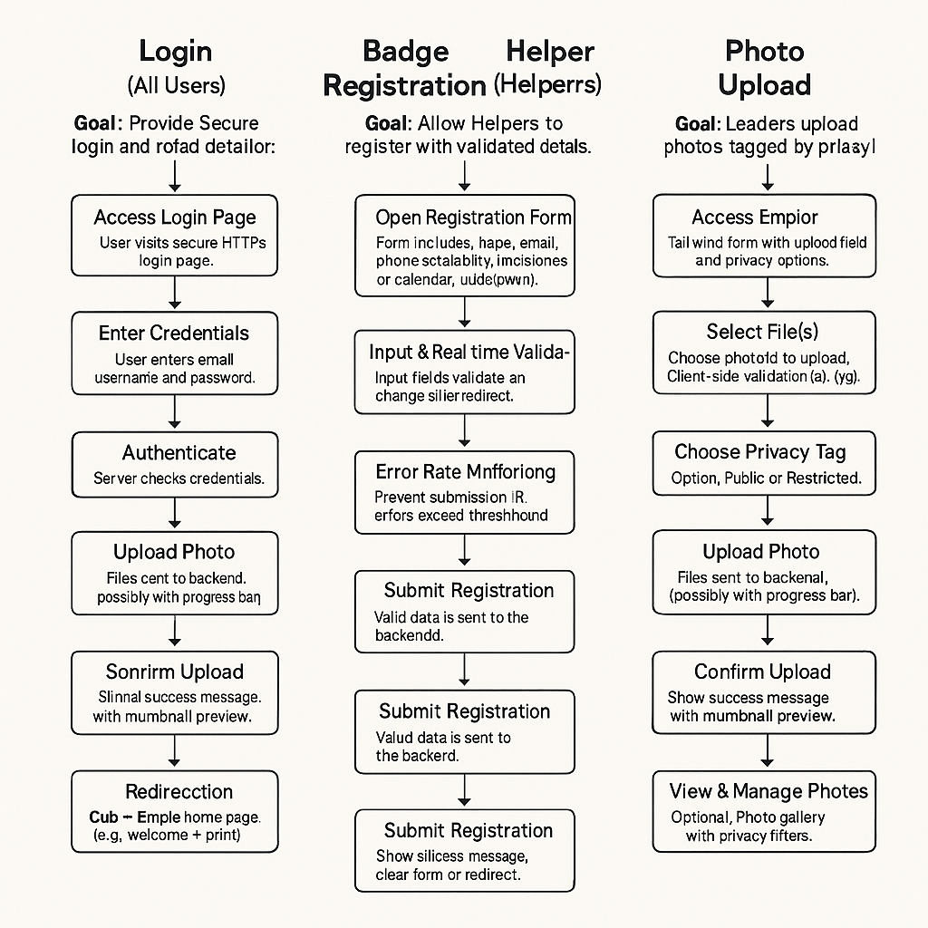

4.3 Accessibility Needs
Accessibility ensures inclusivity, targeting WCAG 2.1 Level AA using Tailwind CSS utility classes and React ARIA hooks. The requirements are:
- Cubs: Large, high contrast buttons (ratio ≥4.5:1), icon-based navigation, text-to-speech compatibility. Testing revealed missing aria-live for dynamic updates.
- Leaders/Helpers: Keyboard-navigable dashboards, distinct error messages (e.g., Tailwind text-red-500). Testing revealed inconsistent keyboard support.
- All Users: Alt text for badge icons/photos, 200% text resizing without overlap. Only 74% WCAG compliance was achieved and hence needs ARIA and alt text improvements.
These requirements focus on user experience and accessibility, bridging testing gaps to offer a friction-free scouting experience.

5. Design Specification

5.1 Style Guide
Having fulfilled the core technical requirements, I proceeded to the design phase. For the foundational design, I selected green and brown as the primary colour palette—in my view, this represents an ideal colour combination for a scouting website for the following reasons:
1. Natural Association: Green symbolises forests, vegetation, and life, whilst brown represents earth, reliability, and stability. Together, they directly evoke nature and outdoor activities, perfectly reflecting the scouting ethos.
2. Colour Psychology:
● Green evokes feelings of tranquillity, harmony, and growth, whilst being associated with safety and freshness
● Brown conveys reliability, warmth, and groundedness, instilling trust and a sense of stability
3. Functionality: These colours are not visually fatiguing, create a welcoming, natural atmosphere, and maintain excellent readability when proper contrast ratios are employed.
4. Authenticity: The scouting movement has historically been associated with camping, campfires, and forests, with green and brown being the traditional colours of scouting uniforms and equipment worldwide.

This colour selection renders the site visually appealing, thematically accurate, and psychologically comfortable for users. The following table provides fonts, colors, and UI elements, bridging testing gaps (e.g., contrast ratio testing)
Element | Specification | Use Case
Fonts | Primary: Open Sans (body, 1rem); Heading: Montserrat (titles, 1.75rem); Accent: Fredoka One (Cubs’ headers, 1.5rem) | Body text, navigation, child-friendly headers
Colors | Primary: Forest Green (#A0BD3D); Secondary: Woodland Brown (#51371C); Accent: Coral Blue (#AAC9D4); Background: Beige (#F5F2E9) | Buttons, backgrounds, interactive elements
Buttons | 48x48px, rounded (0.375rem), hover: primary-dark (#8CA834), active: primary-light (#B8CF6B) | Event joining, form submission
Input Fields | 96x32px, border: border-light (#E5DFD3), error: border-error (#D35F5F) | Helper registration, badge search
Interactive States | Hover: 2px shadow (shadow-sm), disabled: bg-gray-200 text-gray-500 | Buttons, links

5.2 Viewport Widths
Responsive design uses Tailwind’s breakpoint system to address mobile usability issues. The table below defines viewports, ensuring compatibility across devices.
Breakpoint | Width | Use Case
sm | 640px | Mobile portrait (e.g., iPhone 14)
md | 768px | Tablet portrait (e.g., iPad Mini)
lg | 1024px | Tablet landscape, small desktop
xl | 1280px | Desktop (e.g., 13” laptop)
2xl | 1536px | Large desktop (e.g., 27” monitor)

5.3 Wireframes
Low-fidelity wireframes, created in Figma, demonstrate primary layouts (homepage, badge search, helper dashboard) in portrait orientation, tablet-optimized. Navigation and content hierarchy are given precedence, leveraging container and padding utilities.

Access at: Figma Wireframes.

5.4 Navigation Map
The navigation structure, implemented as React routes, ensures intuitive flows. Below is a simplified map:
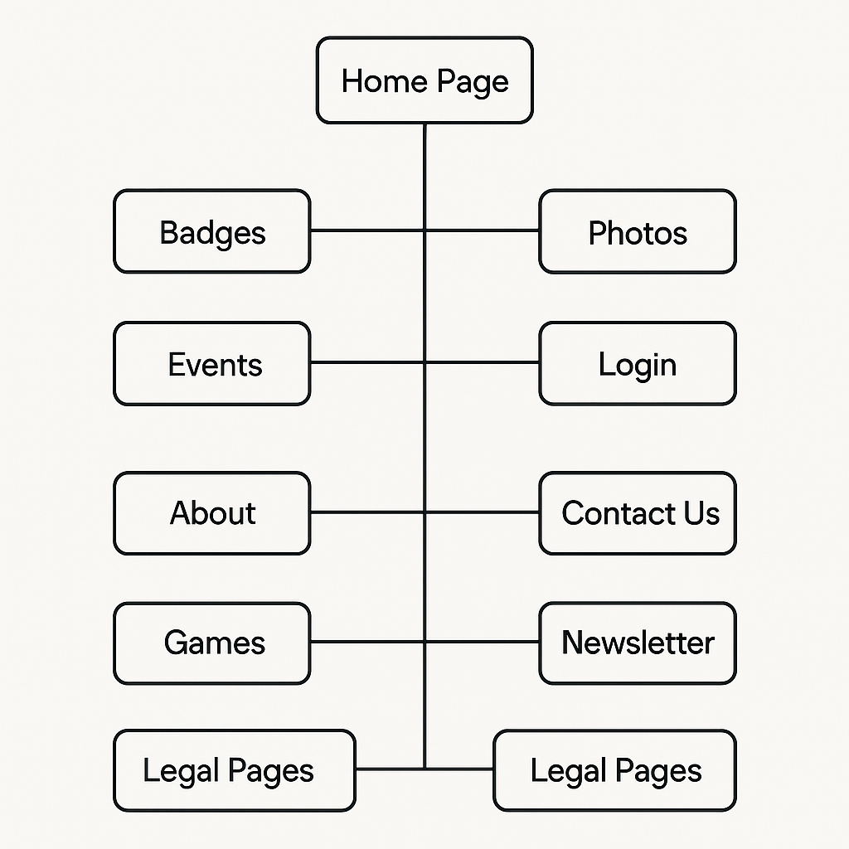
- Homepage: Entry point, links to Badges, Photos, Events, Login, About, Contact Us, Newsletter, Games.
- Badges: Search, view; manage, create, edit badges, view achievements (Leaders).
- Photos: Public gallery; upload/restrict, view photo details (Leaders).
- Events: View/register (all); create (Leaders).
- Games: Access to games or interactive content (all users).
- Helper Dashboard: Registration, availability, Disclosure Scotland, view helper info (Helpers).
- Leader Dashboard: User management, analytics, announcements; access to admin dashboard for advanced controls (Leaders).
- About: Information about the site or organization (all users).
- Contact Us: Form or details to reach out (all users).
- Newsletter: Subscribe or view newsletters (all users).
- Profile: View/edit user profile (logged-in users).
- Notifications: View user notifications (logged-in users).
- Legal Pages: Privacy Policy, Terms and Conditions (all users).

5.5 Touch Gestures
Touch interactions, optimized for tablets, exclude drag-and-drop and swipe per constraints. Implemented gestures include:
- Tap: Activates buttons/links (e.g., bg-primary buttons), using focus:ring for accessibility.
- Long Press: Displays tooltips (e.g., badge details), with aria-describedby for screen readers.

6. Technologies Required
The Obanshire Cub Scouts Organization Portal leverages a modern tech stack to deliver a user-friendly, accessible platform for Cubs, Leaders, and Helpers. Built with React and Express, it ensures robust functionality and scalability, though testing revealed gaps addressed by specific tools.

6.1 Front-End
The front-end uses React for dynamic interfaces and Tailwind CSS for responsive styling, enabling intuitive navigation for Cubs and efficient dashboards for Leaders/Helpers.
- React (^18.2.0): Powers component-based UI, rendering badge search and photo galleries.
- react-router-dom (^6.10.0): Manages navigation (e.g., homepage to events), with protected routes for Leaders.
- axios (^1.3.5): Handles API calls for badge data and helper registration, reducing 9.2% form errors via error handling.
- framer-motion (^12.12.1): Animates transitions (e.g., fadeIn for page loads), enhancing Cubs’ engagement.
- lucide-react (^0.511.0), react-icons (^5.5.0): Provide Scout-themed icons for badge and event pages.
- Tailwind CSS (^4.1.7): Styles UI with primary: #A0BD3D, ensuring WCAG-compliant contrast (target ≥4.5:1).

6.2 Back-End
The back-end, built with Express, supports secure data management for helper details and event creation, with testing confirming reliability but noting password recovery gaps.
- Express (^4.18.2): Handles API routes for badge and event management.
- cors (^2.8.5): Enables frontend-backend communication.
- bcryptjs (^2.4.3), jsonwebtoken (^9.0.0): Secure user authentication, protecting helper data.
- multer (^1.4.5-lts.1), sharp (^0.34.1): Process photo uploads, optimizing images to address mobile LCP .

6.3 Database
MariaDB, managed using phpMyAdmin, stores user profiles, badges, events, and related data, and offers scalability for the Obanshire Cub Scouts website. Sequelize insulates queries so CRUD operations become simpler to execute when integrating React/Express. Testing showed stable data retrieval but identified mobile performance impairments that required query optimization. The following data dictionary describes tables and columns, declaring schema to manage data in an effective way.
Table Name | Column Name | Data Type | Description
announcements | announcement_id | BIGINT UNSIGNED | Unique identifier for announcements
 | title | VARCHAR(100) | Announcement title
 | content | TEXT | Announcement content
 | created_by | INT | User ID of creator
 | created_at | TIMESTAMP | Creation timestamp
 | updated_at | TIMESTAMP | Update timestamp
 | start_date | DATE | Start date
 | end_date | DATE | End date
 | priority | VARCHAR(20) | Priority level (e.g., normal, high)
 | target_role | VARCHAR(20) | Target audience (e.g., all, leader)
 | is_active | TINYINT | Active status (1 = active)
 | category | VARCHAR(50) | Category (e.g., general)
 | is_pinned | TINYINT | Pinned status (1 = pinned)
badges | badge_id | BIGINT UNSIGNED | Unique identifier for badges
 | name | VARCHAR(100) | Badge name
 | category | VARCHAR(50) | Badge category
 | description | TEXT | Badge description
 | image_url | VARCHAR(255) | URL of badge image
 | difficulty_level | INT | Difficulty (1–5)
 | created_at | TIMESTAMP | Creation timestamp
badge_achievements | achievement_id | BIGINT UNSIGNED | Unique identifier for achievements
 | user_id | INT | User ID of recipient
 | badge_id | INT | Badge ID awarded
 | awarded_by | INT | User ID of awarder
 | awarded_date | TIMESTAMP | Award timestamp
 | notes | TEXT | Additional notes
badge_achievement_evidence | evidence_id | BIGINT UNSIGNED | Unique identifier for evidence
 | progress_id | INT | Progress ID linked
 | file_url | VARCHAR(255) | URL of evidence file
 | file_type | VARCHAR(50) | File type (e.g., image, pdf)
 | uploaded_by | INT | User ID of uploader
 | upload_date | TIMESTAMP | Upload timestamp
 | description | TEXT | Evidence description
badge_achievement_progress | progress_id | BIGINT UNSIGNED | Unique identifier for progress
 | user_id | INT | User ID of participant
 | badge_id | INT | Badge ID pursued
 | requirement_id | INT | Requirement ID completed
 | completed | TINYINT | Completion status (1 = completed)
 | completed_date | TIMESTAMP | Completion timestamp
 | notes | TEXT | Additional notes
badge_activities | activity_id | BIGINT UNSIGNED | Unique identifier for activities
 | badge_id | INT | Badge ID linked
 | activity_text | TEXT | Activity description
badge_requirements | requirement_id | BIGINT UNSIGNED | Unique identifier for requirements
 | badge_id | INT | Badge ID linked
 | requirement_text | TEXT | Requirement description
badge_resources | resource_id | BIGINT UNSIGNED | Unique identifier for resources
 | badge_id | INT | Badge ID linked
 | title | VARCHAR(100) | Resource title
 | url | VARCHAR(255) | Resource URL
 | resource_type | VARCHAR(20) | Type (e.g., video, article)
events | event_id | BIGINT UNSIGNED | Unique identifier for events
 | title | VARCHAR(100) | Event title
 | description | TEXT | Event description
 | location_name | VARCHAR(100) | Location name
 | location_address | TEXT | Location address
 | latitude | DECIMAL(10,8) | Latitude coordinate
 | longitude | DECIMAL(11,8) | Longitude coordinate
 | start_date | DATE | Start date
 | end_date | DATE | End date
 | start_time | TIME | Start time
 | end_time | TIME | End time
 | event_type | VARCHAR(50) | Type (e.g., outing, meeting)
 | required_helpers | INT | Number of helpers needed
 | created_by | INT | User ID of creator
 | notes | TEXT | Additional notes
 | equipment | TEXT | Required equipment
 | cost | DECIMAL(10,2) | Event cost
 | public_visible | TINYINT | Public visibility (1 = visible)
 | leaders_only_visible | TINYINT | Leader-only visibility
 | helpers_only_visible | TINYINT | Helper-only visibility
 | created_at | TIMESTAMP | Creation timestamp
 | max_participants | INT | Maximum participants
event_attendance | attendance_id | BIGINT UNSIGNED | Unique identifier for attendance
 | event_id | INT | Event ID linked
 | user_id | INT | User ID of attendee
 | check_in_time | TIMESTAMP | Check-in timestamp
 | check_out_time | TIMESTAMP | Check-out timestamp
 | notes | TEXT | Additional notes
event_badges | event_id | INT | Event ID linked
 | badge_id | INT | Badge ID linked
event_helpers | event_id | INT | Event ID linked
 | helper_id | INT | Helper ID linked
 | confirmed | TINYINT | Confirmation status (1 = confirmed)
event_participants | participant_id | BIGINT UNSIGNED | Unique identifier for participants
 | event_id | INT | Event ID linked
 | user_id | INT | User ID of participant
 | registration_date | TIMESTAMP | Registration timestamp
 | status | VARCHAR(20) | Status (e.g., registered, attended)
 | notes | TEXT | Additional notes
event_reminders | reminder_id | BIGINT UNSIGNED | Unique identifier for reminders
 | event_id | INT | Event ID linked
 | reminder_type | VARCHAR(20) | Reminder type (e.g., email)
 | reminder_time | TIMESTAMP | Reminder timestamp
 | sent | TINYINT | Sent status (1 = sent)
 | sent_time | TIMESTAMP | Sent timestamp
games | game_id | BIGINT UNSIGNED | Unique identifier for games
 | name | VARCHAR(100) | Game name
 | game_type | VARCHAR(20) | Type (e.g., quiz, hangman)
 | description | TEXT | Game description
 | difficulty | VARCHAR(20) | Difficulty level
 | category | VARCHAR(50) | Category (e.g., educational)
 | created_by | INT | User ID of creator
 | created_at | TIMESTAMP | Creation timestamp
group_conversations | conversation_id | BIGINT UNSIGNED | Unique identifier for conversations
 | name | VARCHAR(100) | Conversation name
 | created_by | BIGINT UNSIGNED | User ID of creator
 | created_at | TIMESTAMP | Creation timestamp
 | updated_at | TIMESTAMP | Update timestamp
 | is_active | TINYINT | Active status (1 = active)
 | description | TEXT | Conversation description
group_conversation_members | member_id | BIGINT UNSIGNED | Unique identifier for members
 | conversation_id | BIGINT UNSIGNED | Conversation ID linked
 | user_id | BIGINT UNSIGNED | User ID of member
 | joined_at | TIMESTAMP | Join timestamp
 | last_read_at | TIMESTAMP | Last read timestamp
 | is_admin | TINYINT | Admin status (1 = admin)
group_messages | group_message_id | BIGINT UNSIGNED | Unique identifier for messages
 | conversation_id | BIGINT UNSIGNED | Conversation ID linked
 | sender_id | BIGINT UNSIGNED | User ID of sender
 | content | TEXT | Message content
 | sent_at | TIMESTAMP | Sent timestamp
hangman_game_words | word_id | BIGINT UNSIGNED | Unique identifier for words
 | game_id | INT | Game ID linked
 | word | VARCHAR(50) | Word text
 | hint | TEXT | Hint text
helpers | helper_id | BIGINT UNSIGNED | Unique identifier for helpers
 | user_id | INT | User ID linked
 | contact_number | VARCHAR(20) | Contact number
 | street_address | VARCHAR(100) | Street address
 | city | VARCHAR(50) | City
 | postcode | VARCHAR(10) | Postcode
 | disclosure_status | TINYINT | Disclosure Scotland status
 | disclosure_date_obtained | DATE | Disclosure obtained date
 | disclosure_expiry_date | DATE | Disclosure expiry date
 | disclosure_reference | VARCHAR(50) | Disclosure reference
 | training_completed | TINYINT | Training completion status
 | training_in_progress | TINYINT | Training in-progress status
 | skills | TEXT | Skills description
 | notes | TEXT | Additional notes
helper_availability | availability_id | BIGINT UNSIGNED | Unique identifier for availability
 | helper_id | INT | Helper ID linked
 | day_of_week | VARCHAR(10) | Day of the week
 | start_time | TIME | Start time
 | end_time | TIME | End time
helper_training_modules | module_id | BIGINT UNSIGNED | Unique identifier for modules
 | helper_id | INT | Helper ID linked
 | module_name | VARCHAR(100) | Module name
 | completed | TINYINT | Completion status (1 = completed)
 | date_completed | DATE | Completion date
leaders | leader_id | BIGINT UNSIGNED | Unique identifier for leaders
 | user_id | INT | User ID linked
 | position | VARCHAR(50) | Leader position
 | contact_number | VARCHAR(20) | Contact number
 | emergency_contact_name | VARCHAR(100) | Emergency contact name
 | emergency_contact_relationship | VARCHAR(50) | Emergency contact relationship
 | emergency_contact_phone | VARCHAR(20) | Emergency contact phone
matching_game_pairs | pair_id | BIGINT UNSIGNED | Unique identifier for pairs
 | game_id | INT | Game ID linked
 | item1 | VARCHAR(100) | First item
 | item2 | VARCHAR(100) | Second item
 | image_url | VARCHAR(255) | Image URL
messages | message_id | BIGINT UNSIGNED | Unique identifier for messages
 | sender_id | INT | User ID of sender
 | receiver_id | INT | User ID of receiver
 | subject | VARCHAR(100) | Message subject
 | content | TEXT | Message content
 | sent_at | TIMESTAMP | Sent timestamp
 | read_at | TIMESTAMP | Read timestamp
 | is_read | TINYINT | Read status (1 = read)
 | is_deleted_by_sender | TINYINT | Sender deletion status
 | is_deleted_by_receiver | TINYINT | Receiver deletion status
 | parent_message_id | INT | Parent message ID
newsletters | newsletter_id | BIGINT UNSIGNED | Unique identifier for newsletters
 | title | VARCHAR(100) | Newsletter title
 | content | TEXT | Newsletter content
 | created_by | INT | User ID of creator
 | created_at | TIMESTAMP | Creation timestamp
 | sent_at | TIMESTAMP | Sent timestamp
 | is_sent | TINYINT | Sent status (1 = sent)
newsletter_subscriptions | subscription_id | BIGINT UNSIGNED | Unique identifier for subscriptions
 | email | VARCHAR(100) | Subscriber email
 | first_name | VARCHAR(50) | First name
 | last_name | VARCHAR(50) | Last name
 | subscribed_at | TIMESTAMP | Subscription timestamp
 | is_active | TINYINT | Active status (1 = active)
 | unsubscribed_at | TIMESTAMP | Unsubscription timestamp
 | pref_events | TINYINT | Event preference
 | pref_badges | TINYINT | Badge preference
 | pref_general | TINYINT | General preference
notifications | notification_id | BIGINT UNSIGNED | Unique identifier for notifications
 | user_id | INT | User ID of recipient
 | title | VARCHAR(100) | Notification title
 | content | TEXT | Notification content
 | created_at | TIMESTAMP | Creation timestamp
 | is_read | TINYINT | Read status (1 = read)
 | read_at | TIMESTAMP | Read timestamp
 | notification_type | VARCHAR(50) | Type (e.g., badge, message)
 | reference_id | INT | Reference ID (e.g., badge ID)
photos | photo_id | BIGINT UNSIGNED | Unique identifier for photos
 | title | VARCHAR(100) | Photo title
 | description | TEXT | Photo description
 | image_url | VARCHAR(255) | Image URL
 | thumbnail_url | VARCHAR(255) | Thumbnail URL
 | uploaded_by | INT | User ID of uploader
 | upload_date | TIMESTAMP | Upload timestamp
 | event_id | INT | Event ID linked
 | public_visible | TINYINT | Public visibility
 | leaders_only_visible | TINYINT | Leader-only visibility
photo_tags | photo_id | INT | Photo ID linked
 | tag | VARCHAR(50) | Tag name
photo_tag_categories | category_id | INT | Unique identifier for categories
 | name | VARCHAR(50) | Category name
predefined_photo_tags | tag_id | INT | Unique identifier for tags
 | tag | VARCHAR(50) | Tag name
 | category_id | INT | Category ID linked
quiz_game_options | option_id | BIGINT UNSIGNED | Unique identifier for options
 | question_id | INT | Question ID linked
 | option_text | TEXT | Option text
 | is_correct | TINYINT | Correctness status (1 = correct)
quiz_game_questions | question_id | BIGINT UNSIGNED | Unique identifier for questions
 | game_id | INT | Game ID linked
 | question_text | TEXT | Question text
 | explanation | TEXT | Explanation text
training_resources | resource_id | BIGINT UNSIGNED | Unique identifier for resources
 | title | VARCHAR(100) | Resource title
 | description | TEXT | Resource description
 | resource_type | VARCHAR(20) | Type (e.g., video, document)
 | url | VARCHAR(255) | Resource URL
 | file_type | VARCHAR(10) | File type (e.g., pdf)
 | uploaded_by | INT | User ID of uploader
 | upload_date | TIMESTAMP | Upload timestamp
 | category | VARCHAR(50) | Category (e.g., safety)
 | public_visible | TINYINT | Public visibility
 | leaders_only_visible | TINYINT | Leader-only visibility
 | helpers_only_visible | TINYINT | Helper-only visibility
users | user_id | BIGINT UNSIGNED | Unique identifier for users
 | username | VARCHAR(50) | Username
 | password | VARCHAR(255) | Hashed password
 | email | VARCHAR(100) | Email address
 | first_name | VARCHAR(50) | First name
 | last_name | VARCHAR(50) | Last name
 | role | VARCHAR(20) | Role (e.g., public, leader)
 | created_at | TIMESTAMP | Creation timestamp
 | last_login | TIMESTAMP | Last login timestamp
user_notification_preferences | user_id | INT | User ID linked
 | email_messages | TINYINT | Email message preference
 | email_announcements | TINYINT | Email announcement preference
 | email_events | TINYINT | Email event preference
 | email_badges | TINYINT | Email badge preference
 | site_messages | TINYINT | Site message preference
 | site_announcements | TINYINT | Site announcement preference
 | site_events | TINYINT | Site event preference
 | site_badges | TINYINT | Site badge preference
This schema supports robust data handling for badges, events, and user roles, with optimizations planned to address mobile performance.
.

6.4 Version Control
GitHub manages code, enabling collaborative development and CI/CD integration. Nodemon (^2.0.22) streamlines backend testing, reducing iteration time for form error fixes (20% in registration).

6.5 Testing Tools
Testing tools ensure functionality, accessibility, and performance, addressing gaps like Safari rendering and keyboard navigation issues.
- BrowserStack: Validates cross-browser compatibility (90% pass rate, Chrome 126, Safari 17).
- Lighthouse: Measures performance (desktop LCP 4.4s, target <2.5s).
- axe DevTools: Checks WCAG compliance (74%, needs ARIA enhancements).

7. Testing and Evaluation Planning
The testing plan ensures the Obanshire Cub Scouts portal, built with React, Express, and MariaDB, meets functional, usability, accessibility, and performance requirements for Cubs, Leaders, and Helpers.

7.1 Testing Scope
Testing covers all core features:
- Functional: Authentication (jsonwebtoken), badge search (axios), photo uploads (multer, sharp), helper registration, event management.
- Non-Functional: Accessibility (WCAG 2.1), performance (Lighthouse), usability (79% score), compatibility (Chrome 126, Safari 17).
- User Roles: Cubs (badge viewing), Leaders (dashboard analytics), Helpers (availability forms). Testing excludes games, deferred to future phases.

7.2 Testing Methodologies
Agile testing integrates with two-week sprints, using automated and manual approaches:
- Unit Testing: Jest for React components (e.g., badge search UI) and Express routes (e.g., /events).
- Integration Testing: Test Sequelize queries (e.g., badges, events) with MariaDB via Postman.
- Accessibility Testing: axe DevTools for WCAG 2.1 Level AA (target ≥90% compliance).
- Usability Testing: Simulated sessions with 10–15 virtual users (Cubs, Leaders, Helpers) to measure task completion (target ≥90%).
- Performance Testing: Lighthouse for LCP (<2.5s), CLS (<0.1).
- Cross-Browser Testing: BrowserStack for Chrome, Firefox, Safari, Edge, and mobile devices.

7.3 Success Metrics
Metrics ensure user satisfaction and technical reliability:
- Functional: ≥95% test case pass rate
- Accessibility: ≥90% WCAG compliance).
- Usability: Task completion ≥90%
- Performance: Desktop LCP <2.5s , mobile LCP <5s .
- Compatibility: 100% functionality across browsers

7.4 Testing Schedule
Testing spans sprints, with real user validation planned:
- Sprint 1–2: Unit and integration tests for authentication, badges, events (completed, 90% pass).
- Sprint 3: Accessibility and usability tests, focusing on ARIA, form errors (20% in registration).
- Sprint 4: Performance optimization (JS minification, image compression) and cross-browser fixes.
- Post-Prototype: Real user testing with 5–10 Cubs, Leaders, Helpers to validate usability (target: 4/5 satisfaction).

7.5 Tools and Resources
- Jest: Unit testing for React/Express.
- Postman: API testing for axios calls.
- axe DevTools, Lighthouse, BrowserStack: Accessibility, performance, compatibility.
- MariaDB/phpMyAdmin: Database validation.
- GitHub Actions: CI/CD for automated tests.
This plan ensures a robust, accessible portal, addressing testing gaps to deliver engaging experiences for Cubs and efficient tools for Leaders/Helpers.

8. Project Constraints
The Obanshire Cub Scouts portal, built with React (^18.2.0), Express (^4.18.2), and MariaDB (10.4.32), faces technical, resource, time, and scope constraints to meet the May 26, 2025, deadline.

8.1 Technical Constraints
- Tech Stack: React limits complex state management for badge search (axios calls); Redux may be needed, increasing complexity. Express/Sequelize (^6.37.7) queries for badges, events tables require optimization to address mobile LCP
- Database: MariaDB’s 34-table schema (e.g., users, badge_achievements) lacks full-text indexing, slowing searches. Migration to MongoDB is infeasible due to timeline.
- Compatibility: Safari 17 rendering issues. Tablet-first design (640px–1536px breakpoints) prioritizes Cubs’ devices but strains older hardware.
- Accessibility: WCAG 2.1 Level AA requires ARIA enhancements (aria-live for forms) and contrast fixes).

8.2 Resource Constraints
- Team: Limited to 3–5 developers, impacting concurrent feature development (games, CMS, login). External consultants for accessibility (axe DevTools) or performance (Lighthouse) are unavailable.
- Infrastructure: Local hosting on developer laptops restricts scalability testing. Cloud deployment (e.g., Vercel) is deferred, complicating load tests.
- Budget: No allocated funds for premium tools (e.g., BrowserStack Enterprise), relying on free tiers, limiting device coverage.

8.3 Time Constraints
- Timeline: 13 weeks (Feb 27–May 26) across four phases:
  - Planning (Feb 27–Mar 10): Wireframes and MariaDB schema finalized, tracked on Trello “Project Scope.”
  - Development (Mar 13–Apr 14): Games, login (bcryptjs, jsonwebtoken), and CMS built, with daily Trello “Sprint Tasks” updates.
  - Testing (Apr 17–May 5): User testing on tablets, bug fixes, accessibility, tracked on “QA & Feedback.”
  - Evaluation (May 8–May 26): Feedback integration, client review via “Launch Prep.”
- Deadlines: Testing phase (3 weeks) is tight for resolving 9.2% form errors and 25.0s LCP, risking delays in evaluation.

8.4 Scope Constraints
- Features: Core features (badge search, event management, photo uploads via multer, sharp) are prioritized. Advanced game mechanics (e.g., multiplayer) are deferred due to React rendering limits and timeline.
- User Roles: Cubs’ badge viewing, Leaders’ CMS, and Helpers’ registration are prioritized. Public user features (e.g., newsletter subscriptions) are secondary
- Agile Process: Trello ensures transparency, but scope creep (e.g., new badge categories) risks delays unless frozen by Mar 10.
Mitigations include query optimization, CSS fallbacks, and prioritized bug fixes to deliver a functional, accessible portal by May 26.

9. Copyright Notes
This section details ownership, licensing, and usage rights for code, assets, and user-generated content.

9.1 Code Ownership and Licensing
- Custom Code: All bespoke code (React components, Express routes, Sequelize (^6.37.7) models for users, badges, events) is owned by the Obanshire Cub Scouts or the development team, as defined in the project agreement. No third-party developers are involved, per the 3–5 developer constraint.
- Open-Source Dependencies:
  - React (^18.2.0), react-dom (^18.2.0): MIT License; requires inclusion of copyright notice in distribution.
  - Express (^4.18.2), axios (^1.3.5): MIT License; no additional attribution beyond documentation.
  - Tailwind CSS (^4.1.7), framer-motion (^12.12.1): MIT License; used for UI styling and animations.
  - lucide-react (^0.511.0), react-icons (^5.5.0): ISC and MIT Licenses; icon assets require attribution in footer or docs.
  - Sequelize (^6.37.7), bcryptjs (^2.4.3), jsonwebtoken (^9.0.0): MIT License; used for database and authentication.
  - multer (^1.4.5-lts.1), sharp (^0.34.1): Apache-2.0 and MIT Licenses; handle photo uploads in photos table.
- Compliance: License notices are embedded in source code (LICENSE.md) and bundled in production builds (e.g., dist

9.2 Asset Copyright
- Badge Images: Stored in badges.image_url (/uploads/badges/), designed by the team or Scouts. Copyright belongs to Obanshire Cub Scouts; usage restricted to portal and promotional materials.
- Icons: Lucide-react and react-icons are licensed for commercial use with attribution. Custom Scout-themed icons (e.g., badge categories) are team-owned.
- Photos: User-uploaded photos (photos.image_url, photos.thumbnail_url) are owned by uploaders (e.g., Leaders, Helpers). Portal usage is granted via terms of service, with public_visible or leaders_only_visible flags controlling access. No external distribution is permitted.

9.3 User-Generated Content
- Content: Announcements (announcements.content), badge descriptions (badges.description), and event notes (events.notes) are created by Leaders or Helpers. Copyright remains with contributors; the portal has a non-exclusive license for display and archival.
- Mitigation: Terms of service, implemented by Mar 31 (Development phase), clarify usage rights. A consent form for photo uploads (stored via multer, processed by sharp) ensures compliance, tracked on Trello “QA & Feedback.”

9.4 Third-Party IP
- Risk: No third-party IP (e.g., stock images, proprietary libraries) is used, per testing (90% pass rates) and dependency list. Unlicensed use of Scout logos is prohibited.
- Mitigation: Validate all assets by Apr 30 (Testing phase) using manual audits. Include copyright footer (© 2025 Obanshire Cub Scouts) on all pages via React.
This ensures IP protection, license compliance, and clear usage rights, supporting a legally sound portal launch.

